**GROUP ASSIGNMENT 2 REPORT – MEART DRAWING CLASS**

**My name: Phan Vũ – Student ID: 104222099**

1. **Introduction**

* **The objective of the report**

To provide information on my website, including its goals and user experience, and to demonstrate the PHP and MySQL approaches utilised to create it.

1. **Website content**
2. **Purpose & Main Content**

* As I mentioned, our website – MeArt, is designed to provide all the resources, images, and pieces of information everyone needs or wants to know about MeArt drawing class, and offers a registration form for anyone who wants to join.
* Now I want to introduce more about the purpose and the main content of each page:

1. Home (Index.php)

* Provide an introduction and overview of the website's content and meaning. It is the main landing page for visitors, and it should be designed to capture their attention and encourage them to explore the website further.

1. **Information (Product.php)**

* Provide visitors with information about the class and individual behind the website. This page is one of a website’s most frequently visited pages, as visitors are often interested in learning more about the people or the class. We want to provide an overview of the class's general information, the lecturer’s information, some classroom images, tuition fee. It also includes their achievements, awards, and partnerships or assistance.

1. Enrol (payment.php)

* Provide a form for users to enrol in a class related to decoration art and pencil drawing. We created a format that allows users to enroll in a course. The form asks for the user's first and last name, email, address, phone number, and preferred contact method. It also includes a dropdown menu to select the class the user wants to participate in and checkboxes to choose the subjects they want to focus on. Additionally, there is a section for the user to add any comments or additional information.

1. About us (about.php)

* Provide information about the development team behind the website. The page includes details about 5 team members, Le Phan, Binh Ca Nguyen, Nguyen Dang Khoi, Huu Nhan Le and Phan Vu, such as their names, student IDs, courses, email addresses, hobbies, and weekly timetables. Visitors can use this information to contact us for any concerns or information.

1. Enhancement (enhancement2.php)

* List some enhancements about PHP and MySQL techniques we used to develop this website.

1. **Fix Order (fix_order.php)**

* Based on payment.php, many PHP components utilise it to highlight errors when incoming data doesn't match what was expected after it had been verified using the process order.php file.

1. **Receipt (receipt.php)**

* Displays payment information upon user data submission on the enroll page (payment.php).

1. Management (management.php)

* Allows the website's administrator to change an order's status and run queries on orders, displaying the results in an HTML table.

1. **Some technical detail**

Typically, we reuse the majority of the HTML material from Assignment 1 and edit it with some more details, such as payment information for an inquiry page, to turn it into a php file (payment.php). We also develop new PHP files by mixing HTML and PHP source code, including receipt.php, fix order.php, and manager.php, which have various functions like validating, connecting to MySQL databases, including header, footer, and menu code, etc. The website's design is based on the style.css file from the previous Assignment, but it also includes some new code for the newly mentioned php files. Lastly, we store the information obtained from the payment form in the MySQL database.

1. **User interface.**

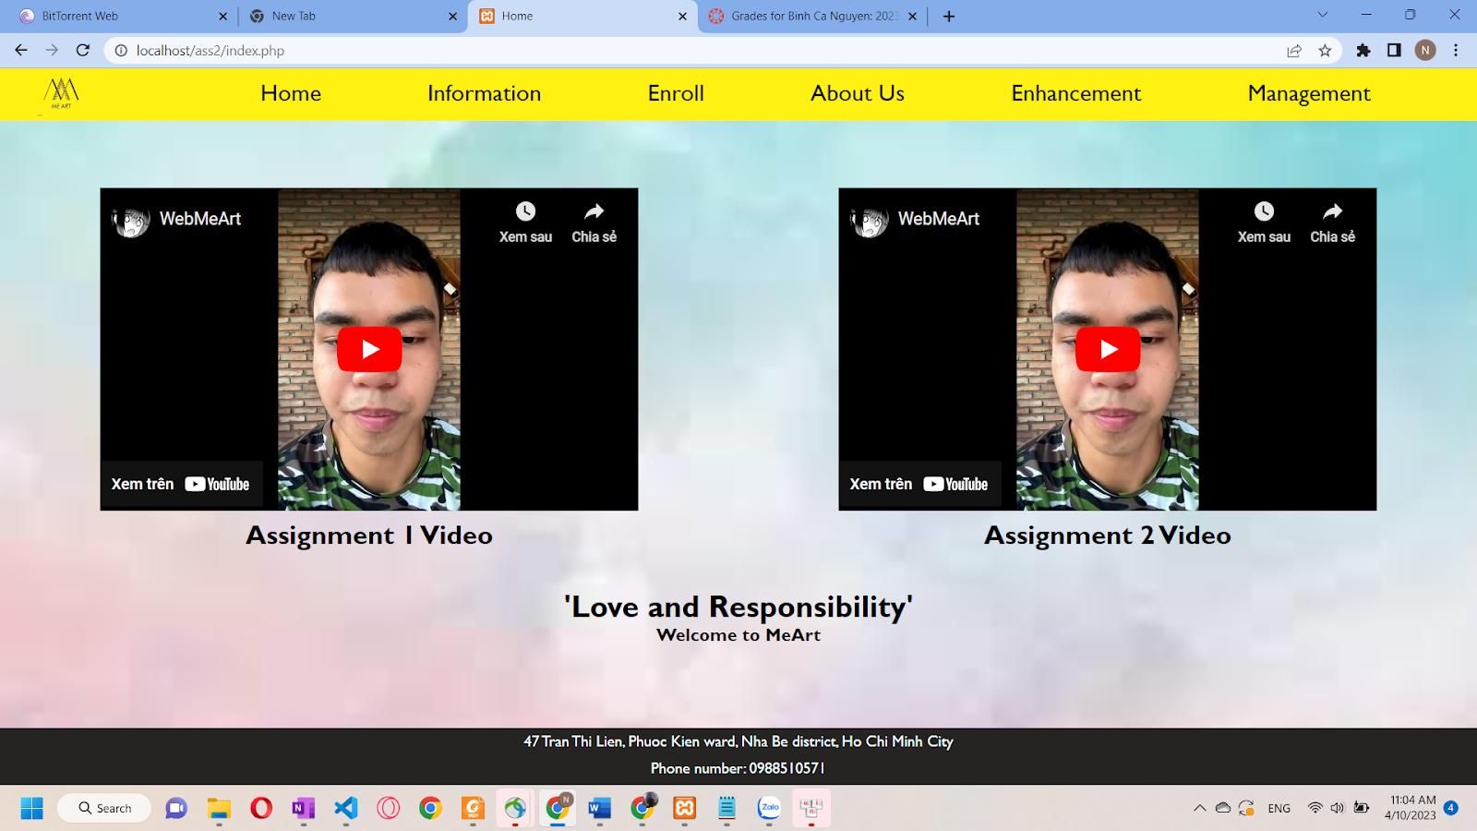

**Index.php interface**

**Product.php interface**

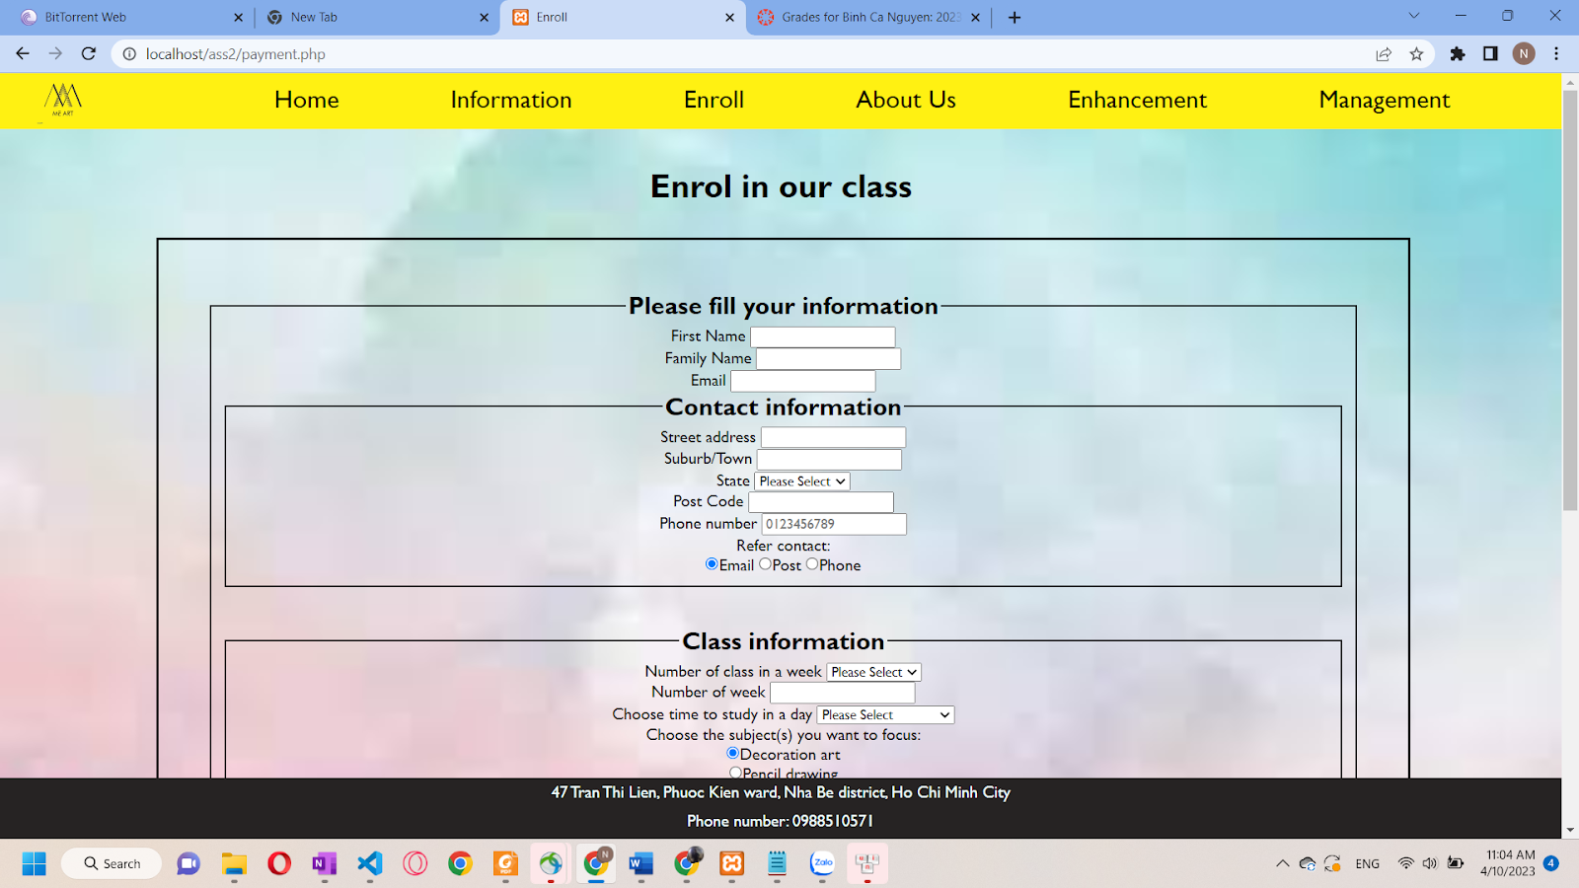

**Payment.php interface**

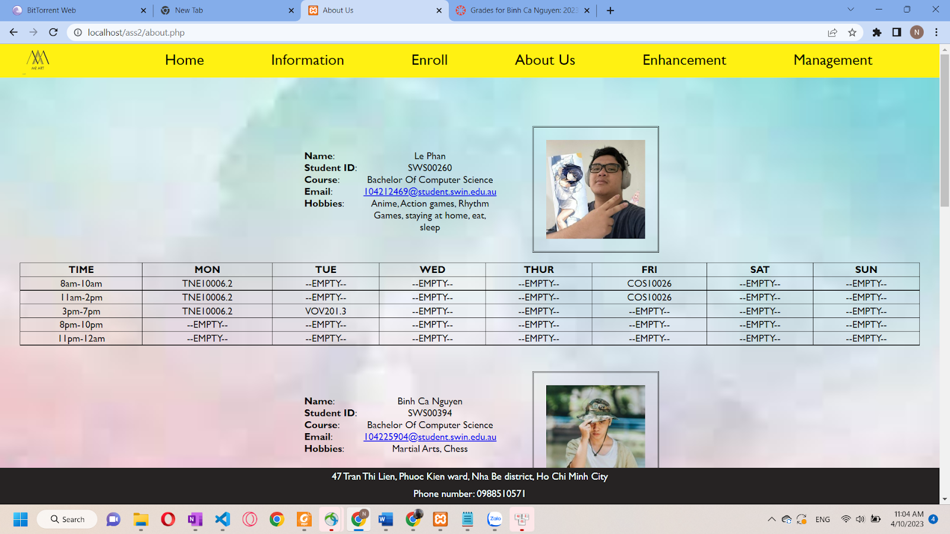

**About.php interface**

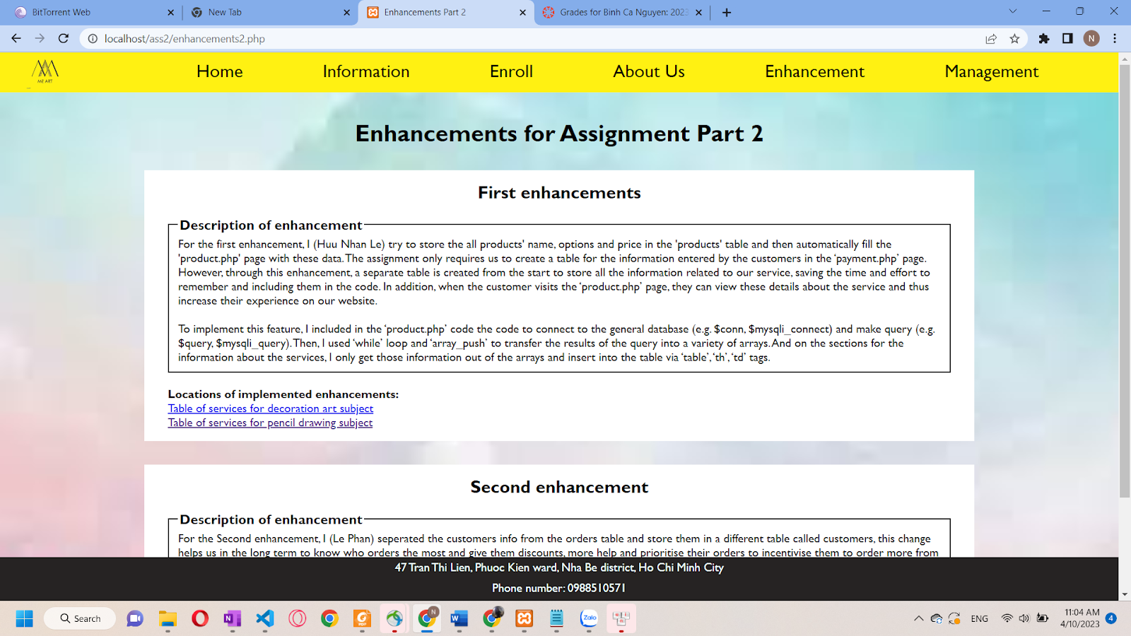

**Enhancements2.php interface**

**Management.php interface**

1. **Key features**

The initial change to the website's design was putting all product information in the database "products" and having the "product.php" page automatically filled with this data. One benefit of this adjustment is that website administration and maintenance will take less time and effort. Consumers' online experience is enhanced by the ability to examine more details about the service on the "product.php" page.

The second enhancement to the website's design was to segregate customer data from order data and store it in a separate database called "customers." Better tracking of client orders, recognition of returning customers, discounts, and giving their purchases precedence are all advantages of this adjustment. The website may provide a better user experience and incentives for returning users by segregating customer and order information. Moreover, It also helps with database maintenance and reduces the possibility of losing essential client data. To implement this functionality, the developer split the insert and create table query into two and utilized two separate queries to insert/change data in the database.

1. **My contribution**

In this assignment, I am responsible for making the management.php. To be more detailed, my job is to create a page that receives the data from the database for the owner or the manager to manage and control customer orders in the fastest and simplest way. On this page, we used most of the PHP and some from MySQL to receive the needed data and show it on the webpage. And this time, I couldn’t finish it without Le Phan’s help. For the last four days, because of sickness, I fainted and was taken to the hospital. So Le Phan helps me remarkably finish the work and the video.

1. **Conclusion**

In conclusion, this report thoroughly described the MeArt website's creation process, including its goal, specifics, and salient characteristics. The research focused on how PHP and MySQL approaches were used to build the website and how they improved the user experience. The two main website improvements were thoroughly covered by storing all product data in the "products" table and segregating customer data from the "orders" table. The report also details how each webpage was built, how the user interface worked, and what each team member contributed. The information also discussed the teamwork experience, emphasising the need for efficient communication and appropriate task delegation for the project's success. Overall, anyone interested in building a website utilizing PHP and MySQL approaches will find this study helpful. It also provided a comprehensive summary of the MeArt website's development process, covering its objective, specifications, and key features. The research concentrated on the website's development using PHP and MySQL strategies and how such strategies enhanced user experience. The two key website enhancements—storing all product information in the "products" database and segregating customer information from the "orders" table—were addressed in great detail. The report included information on the creation process for each webpage, the operation of the user interface, and the contributions made by each team member. The project’s success was stressed in the report's discussion of the collaboration experience, which emphasised the value of excellent communication and proper task delegation.